**VIRTUAL EYE - LIFE GUARD FOR SWIMMING POOLS TO DETECT ACTIVE DROWNING.**

**Introduction** :

✪ This project provides the insights of a real-time video surveillance system capable of automatically detecting drowning incidents in a swimming pool.

✪ Drowning is the 3rd reason for the highest unintentional deaths, and that’s why it is necessary to create trustable security mechanisms.

✪ Currently, most of the swimming pool\'s security mechanisms include CCTV surveillance and lifeguards to help in drowning situations.

**Main Objectives :**

* By studying body movement patterns and connecting cameras to artificial intelligence (AI) systems we can devise an underwater pool safety system that reduces the risk of drowning.
* Usually, such systems can be developed by installing more than 16 cameras underwater and ceiling and analyzing the video feeds to detect any anomalies. but AS a POC we make use of one camera that streams the video underwater and analyses the position of swimmers to assess the probability of drowning, if it is higher then an alert will be generated to attract lifeguards' attention.

**Problem statement :**

* But this method is not enough for huge swimming pools like in amusement parks. Nowadays, some of the security systems are using AI for drowning detection using cameras situated underwater at a fixed location and also by using floating boards having a camera mounted on the bottom side so that underwater view can be captured.
* But the main problems in these systems arise when the pool is crowded and vision of cameras is blocked by people.
* In this project, rather than using underwater cameras, we are using cameras situated on top of the swimming pool to get an upper view of the swimming pool so that entire swimming pool will be under surveillance all time.
* Once we have the working drowning detection model we can feed live video footage of the swimming pool to it so that it can keep detecting continuously for any drowning activities.
* If drowning is detected it will be highlighted on the system screen as well as alarms will be raised to alert security guards so that they can initiate rescue.

**Technical diagram :**

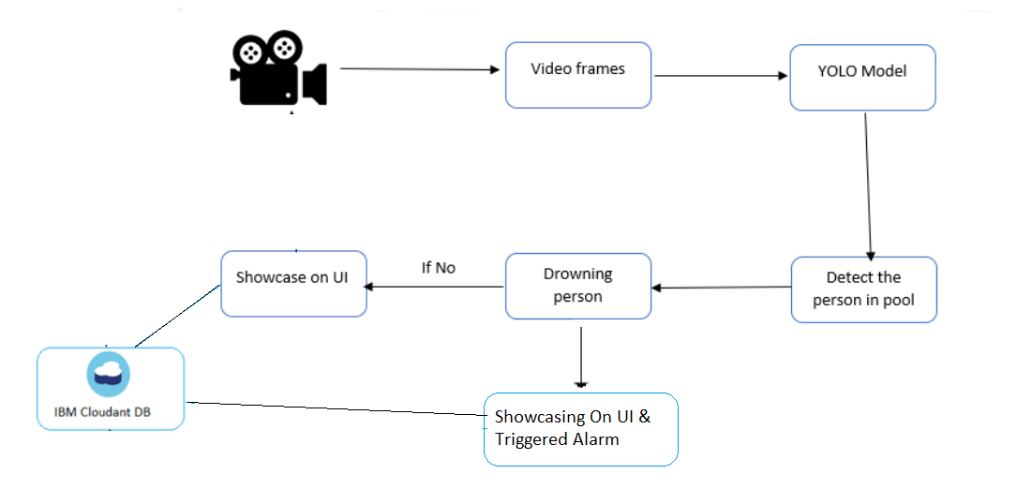

**HOW VIRTUAL EYE IS WORKING TO DETECT DROWNING?**

